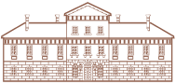
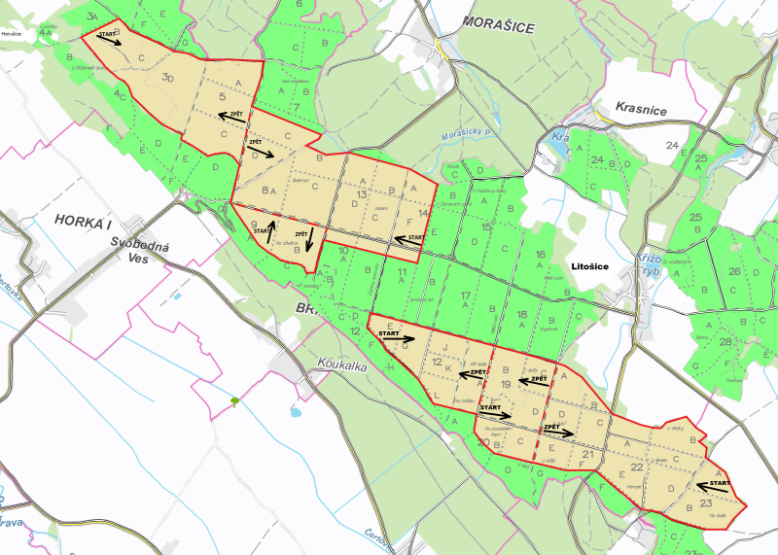
9
7
6
5
First drive
8
3
Správa Panství Žehušice
3
4
6
3A
2A
1A
7A
10A
4
1BmjcBBBBB
10
11
12
Second drive
10A
9A
8A
6A
5A
4A
12
7
11
9
10
8
5
2
1
9A
8A
7A
6A
5A
2A
4A
3A
1A
2
1
First drive
Stand

Second drive
Stand

Third drive
Stand

Fourth drive
Stand

Fifth drive
Stand

Sixth drive
Stand

X Your stand

